光伏组件安装说明书
PV Module Installation Instructions



连云港神舟新能源有限公司
Lianyungang Shenzhou New Energy Co.,Ltd
1 前言
感谢您选择 连云港神舟新能源有限公司 光伏组件。本手册所指的光伏组件是指由本单位所生产和销售的光伏组件。
本说明书提供了神舟单玻光伏组件（以下简称组件）的安装和安全使用信息。
安装前，请仔细阅读和理解本说明书。如有任何问题，请联系我们的销售部门。
安装人员应熟悉太阳能光伏发电系统的机械和电气要求。安装组件时，安装者应遵守本手册和当地相关法律规定的安全注意事项。
本公司不承担任何由于未遵守本说明书引起的组件及系统损坏、人身伤害、财产或其他损失。
本说明书请妥善保管，以备将来系统维护、保养、出售或处理时参考。
本说明书最终解释权归本公司所有。

1 preface Introduction
Thanks for purchasing PV modules of Lianyungang Shenzhou New energy Co., Ltd. . This manual refers to PV modules manufactured or sold by our company.
This manual contains the information of installation and safe handling of Shenzhou’s PV modules (hereafter is referred to as "module”).
All instructions shall be carefully read before installation. Please contact our sales department for further information if have any question.
The installer shall be familiar with the mechanical and electrical requirement of PV system. The installer shall comply with safety precautions listed in this manual and local law regulations when installing the modules.
Our company does not take the responsibility for the loss, damage, or expense arising that caused by any violation of this manual.
This manual shall be properly kept for future reference (care and maintenance) and in case of sale or disposal of the module at the end of its useful life.
Our company reserves the right of final interpretation of this installation manual.
2 警告
2.1 安装太阳能光伏发电系统要求专业的知识和技能，必须由具备专业资格的工程师操作。
2.2 当组件暴露在太阳光或者其他光源下，组件内有直流电流产生，此时与组件的电气部分接触可能会发生触电危险。
2.3将组件应用于地面、屋顶等室外环境。如果组件安装在屋顶的话，必须安装在具有一定防火能力的屋顶上，可以咨询当地的建筑部门来决定使用何种屋顶材料。合理的支撑结构是系统设计人员或安装人员的责任。
2.4不要在有负载的情况下断开连接线。
2.5不要拆解组件、移动任何铭牌或黏附的部件。
2.6 不要将组件放置在容易产生或储存可燃气体的地方。
2.7 不得用人工聚集的阳光照射在组件上。
2.8不能让任何物件掉落或覆盖在组件上，严禁在组件上踩踏、站立或行走。
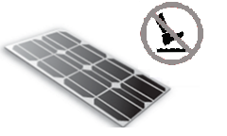
2.9禁止通过组件电缆线拉拽、拖行组件。
2.10 在运输和安装过程中严禁孩子接触组件。
2.11 禁止用手直接接触组件的电气部分，使用符合电力安装工作绝缘要求的工具进行电气连接。
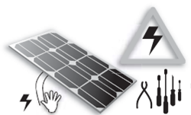
2.12 在运输和安装过程中，操作员请勿佩戴金属环、手镯、耳环、鼻环、唇环或其他金属饰件。组件运到安装地以后，所有的包材都应该小心拆包。
2.13 不要在组件玻璃面钻孔，否则会导致组件失效。不要损坏组件边缘的密封，否则将导致组件失效。破损的太阳电池组件具有危险性（电击和着火），这样的组件不能修复或维修，应该立即换掉。
2.14为降低发生电击或燃烧的风险，可以在安装太阳电池组件时用不透光材料覆盖在组件表面。
2.15 确保支架与光伏组件之间的连接牢固、无松动。
2.16 所有组件系统都需接地，如果没有特殊规定的话，请遵照国际电工标准或其他的国际标准。
2.17 不要用具有腐蚀性的化学药剂来擦拭组件。
2.18 屋顶安装会影响房屋的防火性能；根据IEC61730的规定，组件的耐火等级为C级，应安装在C级以上的屋顶上。光伏系统的消防等级应与屋顶一起评估，只有按照安装说明书中规定的方式安装时，组件的防火等级才有效。

2 Warnings
2.1 It requires specialized skills and knowledge for installation of solar photovoltaic systems. It shall be performed by qualified licensed professional installation personnel.
2.2 When the modules are exposed to sunlight or other light sources, there is DC current generated in the modules, and the electrical part of the modules may be exposed to electric shock hazard.
2.3 Apply modules to such as ground, roofs etc. outdoor environment. If the modules are installed on the roof, they must be installed on the roof with a certain fire protection capability. Consult the local construction department to decide which roof material to use. Appropriate rack structure shall be designed by system designer or installer.
2.4 Do not disconnect the cables of modules when modules are on operation.
2.5 Do not disassemble modules or move nameplate or any adhesion parts of modules.
2.6 Do not place the modules where it is easy to produce or gather combustible gases.
2.7 Artificially concentrated sunlight shall not be directed on the module.
2.8 Any dropping or covering on modules is not allowed. Do not tread, stand or walk on modules.
2.9 Do not pull or drag the modules by cables or connectors.
2.10 Keep children away from modules during transportation and installation.
2.11 Do not touch live terminals with bare hands. Use insulated tools for electrical connections.
2.12 Do not wear metal rings, bracelet, earrings, nose rings, lip rings or other metal accessories during transportation and installation. After the modules are shipped to the installation site, all packages should be carefully unpacked.
2.13 Do not drill on the glass surface of module which will void its warranty. Do not damage the seal on the edge of the modules, otherwise the modules will fail. Damaged modules are dangerous (electric shock and fire). Such modules can not be repaired or repaired and should be replaced immediately.
2.14 In order to reduce the risk of electric shock or combustion, it is possible to cover the surface of the modules with opaque material when installing modules.
2.15 Make sure the connection between the rack and PV module is firmly and without loosen.
2.16 All modules systems must be grounded. If there is no special requirement, please comply with the International Electrical Standards or other international standards.
2.17 Do not wipe modules with corrosive chemicals.
2.18 It may affect fire resistance of the house if roof-mounted; fire rating of the modules is rated as Class C according to IEC61730, which shall be installed on the roof fire-rated above Class C. The system fire rating should always be evaluated along with the roof cover and mounting system. The fire rating of this module is valid only when mounted in the manner specified in the mechanical mounting instructions.

3 产品标识
3.1 每个组件的背面都有标签，提供以下信息：
产品类型、重量、尺寸、熔丝电流、系统最高电压、标准测试条件下测得的额定功率、额定电流、额定电压、开路电压、短路电流。
3.2 条形码（序列号）：每个组件都有一个唯一的序列号。它被永久地固定在组件内部，从组件正面可以看到。
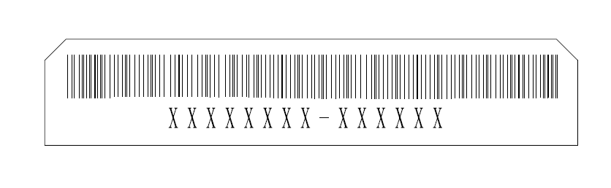
3.2.1 组件条码由14位数码及划线组成。组件的序列号具有唯一性，其含义为：前八位为两位生产工厂码、三位日期码和三位订单流水号组成，八位后为一划线，划线后六位即为组件生产流水号，一个工单的组件数量不得超过999999块。
X X XX X XXX-XXXXXX
代表每个组件产品编号
代表订单流水号
代表月份
代表年份
代表生产工厂
代表连云港神舟
3 Product Identification
3.1 Each module has a label on the back containing following information:
Product type, weight, size, fuse current, the system max voltage, rated power measured under standard test conditions, rated current, rated voltage, open circuit voltage, short circuit current.
3.2 Bar code (serial number): each module is registered with a unique serial number. It is permanently fixed in the module, which can be seen in front of module.
3.2.1 The bar code (serial number) of the module is unique, and consists of 14 bits and a line. The first eight digits of serial number are composed of two manufacture codes, three date codes and three order serial Numbers. The line is followed by six numbers of component production. The number of components each order will not exceed 999999.

X X XX X XXX-XXXXXX
The product number of each component
Represents the serial number of order
Month
Year
Manufacture
Represent Lianyungang Shenzhou New energy Co., Ltd.

4 安装
4.1工具及材料
4.1.1 螺丝刀
4.1.2 扳手
4.1.3 安装支架
4.1.4 不锈钢螺丝、螺帽、垫圈、压板等附件
4.2 安装安全
4.2.1 组件安装的时候要戴上防护头盔、绝缘手套，穿上橡胶鞋。
4.2.2 在安装的过程中，避免不必要地去触摸组件，组件表面和边框可能很热，会有烧伤或者电击的危险。
4.2.3 不要在下雨，下雪或者大风的天气条件下安装。
4.2.4 由于有电击的危险，如果组件的接线盒端子是湿的，请不要进行安装作业。
4.2.5 安装时，禁止乱摔任何东西，包含组件和安装工具。
4.2.6 正确无误的连接接线盒连接器，检查接线状况，所有的连接线不得脱离组件，并采取一定的方式使连接线不会擦伤或者挤压组件。
4.2.7 不管组件有没有连接到光伏系统，在安装过程或者是有光照照在组件上的时候，请不要裸手接处接线盒或者连接器。
4.2.8 不要在组件表面加过重的行李或者物体，或扭曲组件的边框。
4.2.9 禁止在组件的玻璃上放过重的物体或者进行撞击，这可能会损坏电池片或者造成电池片隐裂。
4.2.10 禁止使用尖锐的工具去擦洗组件的玻璃，这会在组件上留下划痕。

4 Installation
4.1 Tools & Materials
4.1.1 Screwdriver
4.1.2 Wrench
4.1.3 Mounting bracket
4.1.4 Stainless steel screws, nuts, washers, clips and other accessories
4.2 Installation Safety
4.2.1 Wear protective headgear, insulating gloves and rubber shoes when modules are installed.
4.2.2 During installation, avoid unnecessary touching of modules. The surface and frame ofmodules may be very hot, and there may be burns or electric shocks.
4.2.3 Do not install in rainy, snowy or windy weather.
4.2.4 Due to the danger of electric shock, if the junction box connecters are wet, please do not install it.
4.2.5 When installing, do not throw anything, including modules and installation tools.
4.2.6 Correct connection junction box, check wiring status, all wiring must not be separated from the modules, and take certain ways to make the wiring will not scratch or extrude the back glass of the modules.
4.2.7 Whether or not the module is connected to the photovoltaic system, during installation or when there is light on the module, please do not connect the junction box or connectors.
4.2.8 Do not overweight luggage or objects on the surface of modules, or distort the frame of modules.
4.2.9 It is forbidden to place heavy objects on the glass of modules or to impact them, which may damage or cause cracks in the solar cells.
4.2.10 It is forbidden to use sharp tools to scrub the glass of the modules, which will leave scratches on the modules.
5 系统设计
请使用与太阳能系统配套的设备、连接器、电线、支架。在特定的系统中，一定要使用相同类型的组件。在确定光伏系统相关部件的额定电压、导线容量、保险丝容量、控制器容量等和组件输出功率有关联的参数时，请参照组件标签上显示的短路电流(Isc)和开路电压(Voc)的值进行合理的设计。
在正常的室外环境下，光伏组件产生的电流和电压可能与参数表中的参数不同。参数表中的参数是在标准测试条件下(STC)测得，所以关于解决不同地区的光伏发电系统的参数，如额定电压、导线容量，保险丝容量，控制器容量和组件输出功率时，应使用组件标签上的Isc和Voc的值应乘以1.25倍的冗余值设计和安装。
确保每个阵列的系统电压不超过组件最大系统电压，以及控制器、逆变器等子设备的额定电流和电压。
组件之间的连接：根据系统设计要求输出电压和电流，组件通过自身导线串联或并联起来；串联组件的最大数量（N）等于最大系统电压Vmax除以单个组件的开路电压Voc；并联组件的数量与标准测试条件下选择的电气设备（逆变器、控制器）有关。
最大系统电压≥N*Voc*[1+ Tc(voc)* (Tmin-25)]。
N 串联组件数量。
Voc 组件开路电压（见产品标签或数据表）。
Tc(voc) 组件开路电压温度系数(参见数据表)。
Tmin 最低环境温度。

5.1 位置选择
5.1.1光伏组件常规工作环境温度为-40°C + 40°C。光伏电池的极限工作温度范围从-40°C到+ 85°C。
5.1.2 HT组件允许的最大安装高度是海拔2000米。
5.1.3在标准测试条件下(1000 W / m²的辐照度,AM 1.5，25℃(77°F)环境温度)，组件的电气性能参数，如Pmax标称值相比偏差为±3%；Isc、Voc标称值相比偏差为±5%。
5.1.4 应选择适合的安装位置安装组件。
5.1.5在北半球组件建议朝南，在南半球建议朝北。
5.1.6太阳能组件的倾斜角指的是组件表面与地平面之间的夹角，如下图1所示，组件表面与太阳光垂直的时候功率输出最大。要了解最佳的安装倾斜角的详细信息，请参考咨询当地可靠的太阳能系统安装公司。
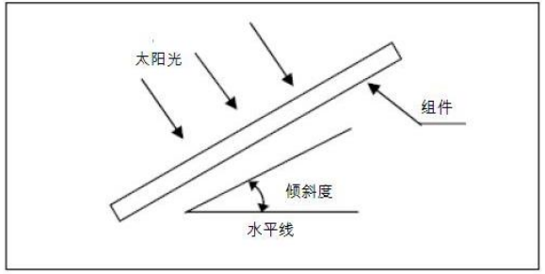
图1太阳能组件安装倾斜角
5.1.7组件应安装在阳光充分照射的地方，不能在任何时间被遮挡。
5.1.8 一般来说，不建议安装在距海边500米以内的地方。组件安装在距海边3千米以外的地方，可以保证25年的使用寿命。如果组件安装在距海边500米至3000米的地方，组件需要增加额外的保护（如增加铝合金边框的氧化膜厚度，并且对安装部位做好防锈蚀的处理）。
5.1.9 当组件发电系统用到蓄电池时，蓄电池必须正确安装，这样可以保护组件发电系统的安全运行。蓄电池的安装使用维护需按照蓄电池生产商说明书进行。
5.2 选择合适的逆变器
在选择逆变器类型时，需要考虑光伏组件阵列的输出功率、开路电压、短路电流。组件阵列的最小电压应大于逆变器的开启电压，以保证逆变器的正常工作。
5.3 选择合适的支架
系统设计者或安装者负责载荷计算，使组件能够承受所有预定的载荷条件；这是支架安装商所必须要提供的保证。所选用的支架必须经过具有静态力学分析能力的第三方测试机构检验和测试。

5 System design
Please use the the equipments, connectors, wires and rack which match with solar power system. In a particular system, be sure to apply the same type of modules. Please refer to the short-circuit current (Isc) and open circuit voltage (Voc) showing on modules’ label as proper value to install and design when determining settling parameters such as rated voltage, the wire capacity, fuse, the controller capacity and module output power of relevant parts of PV system.
In normal outdoor conditions, the generated current and voltage maybe different from the parameters listed in Table. Parameter table is measured under standard test conditions (STC), so concerning settling parameters of other parts of photovoltaic power generation system, such as rated voltage, the wire capacity, fuse, the controller capacity and module power output, it shall refer to the short-circuit current (Isc) and open circuit voltage (Voc) noted on modules’ label, with the redundancy value of 125% for design and installation.
Make sure the array of modules installed within the Maximum permitted system voltage and the rating current and voltage of the sub-equipments such as regulators and inverters.
The connection of modules: in accordance with system design, requirements of output voltage and current, modules can be series or parallel connected by their connecting wires; the maximum number of modules in series (N) is equal to the maximum system voltage Vmax divided by the open circuit voltage Voc of one single module; the number of modules in parallel is related to the selection of electrical equipment (inverters, controllers) under standard test conditions.
Max System voltage≥N*Voc*[1+ Tc(voc)* (Tmin-25)];
N No modules in series;
Voc Open circuit voltage of each module(refer to product label or data sheet);
Tc(voc) Thermal coefficient of open circuit voltage for the module(refer to data sheet);
Tmin The lowest ambient temperature.
5.1 Location Selection
5.1.1 The module should be installed at an ambient temperature of –40 °C to +40 °C. The cell’s limit working temperature range is from –40 °C to +85 °C.
5.1.2 The maximum altitude for HT PV module is 2000m.
5.1.3 Under standard test conditions (1000W / m² irradiance, AM 1.5 spectrum, 25 ° C (77 ° F) ambient temperature), the electrical performance parameters of modules, such as Isc, Voc, and Pmax. Tolerance of rating Pmax is±3%,Voc and Isc is±5%.
5.1.4 A suitable installation location shall be carefully selected for modules.
5.1.5 In the northern hemisphere, modules had better be installed facing south direction; in the southern hemisphere, modules had better be installed facing north.
5.1.6 The tilt angle of the PV module is measured between the surface of the PV module and a horizontal ground surface (as shows in Figure 1). The PV module generates maximum output power when it faces the sun vertical. If you want the specific information of best install tilt angle, please consult the local authoritative solar system construction company.
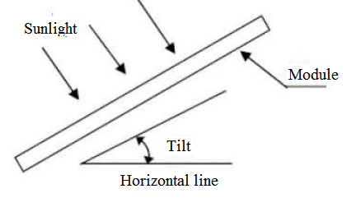
Figure 1 PV module tilt angle
5.1.7 Modules shall be installed in the position of full sun exposure and not be obscured at any time.
5.1.8 Generally, it is not recommended to be installed within 500 meters from the sea..The modules, as a general rule, Can guarantee 25 years of useful life when it is installed in where 3 km away from the sea; if the installation site change to a place on a scale of 500m to 3000m from the sea, the modules need to increase the special protection(such as thickening the thickness of the oxide film of Aluminum metal alloy frame,and the installation position must be processed with anti-corrosion treatment).
5.1.9 When the battery is used in the photovoltaic system, the battery must be installed correctly so as to protect the safe operation of the photovoltaic system. Battery installation, use and maintenance shall be carried out in accordance with battery manufacturer's instructions.
5.2 Choosing the appropriate inverter
It need take the output power, open-circuit voltage, short-circuit current of PV modules array into consideration when choose inverter type. And the minimum voltage of the module array should be higher than the threshold voltage of inverters to guarantee the inverters proper functioning.
5.3 Choose the appropriate rack
The load calculation should be charged by system designers and installers to make sure all modules could bear predetermined load conditions. The choosing rack should pass all the inspection and test by third party test institution which possessing static mechanics analysis ability.

6 组件安装
  - 组件拆箱
6.1.1当组件被运到安装地，应避免在雨天对组件进行拆箱。
6.1.2拆箱后的组件应水平放置，禁止倾斜、堆压重物、斜靠等堆栈方式。
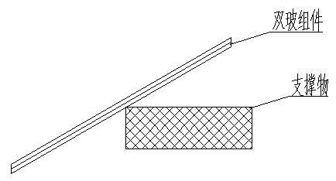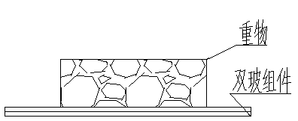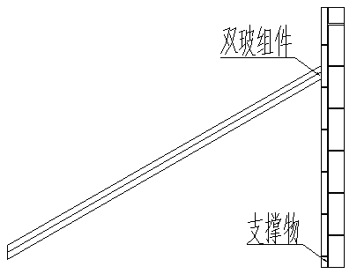
禁止倾斜 禁止堆压重物 禁止斜靠
图2 组件堆放说明
6.1.3 两个批次的组件之间分开堆放。组件重量不超过23kg的组件每托堆放数量不超过23块；组件重量不超过27kg的组件每托堆放数量不超过18块。
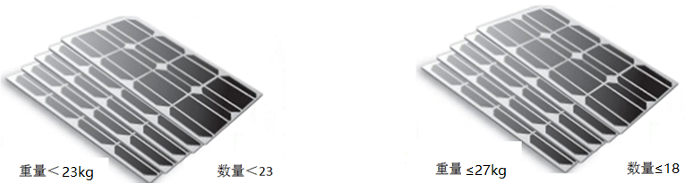
6.1.4包装箱拆箱需按图3进行拆箱，禁止野蛮操作或用撬棍插入箱内撬开, 使用工具时注意人身安全与组件安全。
6.1.5包装箱卸车后，需放置在干燥、平整的地面上，不得放置在潮湿、泥泞、凹凸不平的地面上。
6.1.6组件运抵施工项目地后，需要将上下箱拆开后单独放置，不得将两箱组件摞托放置；如组件无法及时安装，需注意组件及包装箱的保护，防止雨水、大雪、冰雹、台风等自然灾害的破坏。
拆箱过程：
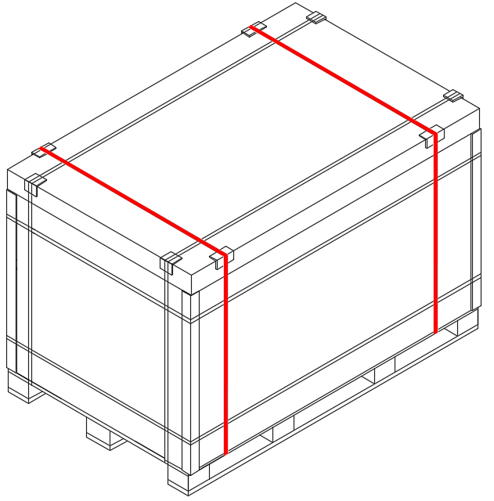 | 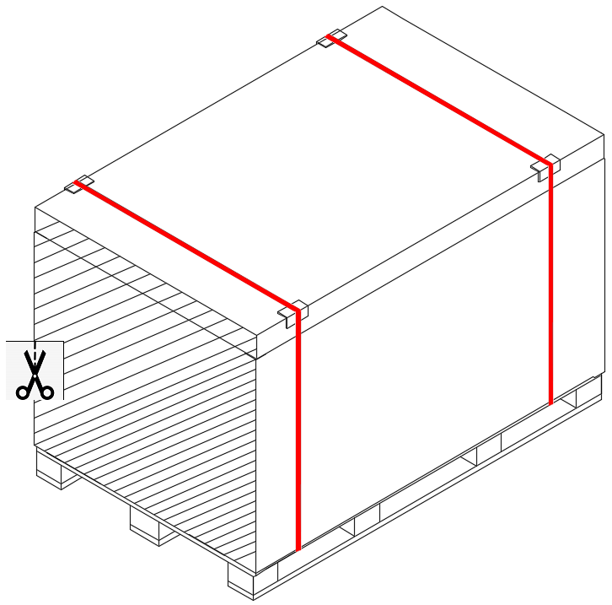
- 拆除外箱打包带，标红打包带不拆 | - 去除包装侧面（阴影部分）
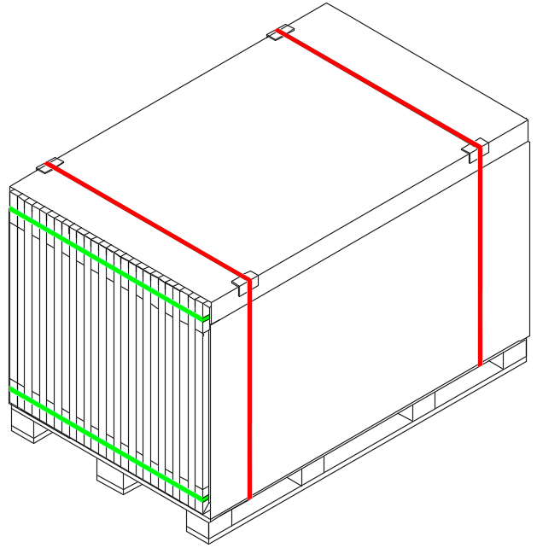 | 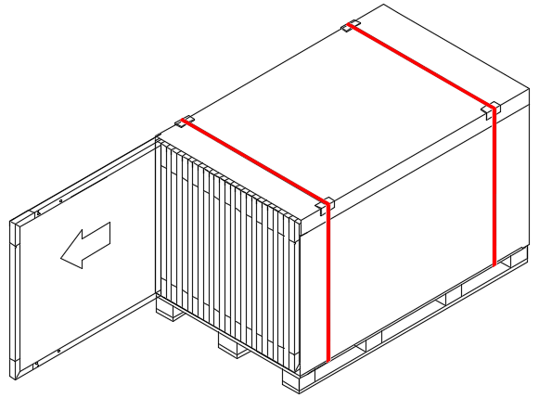
3.去除侧围板折痕以上部分纸箱及护角 | 4.拆卸组件
图3 拆箱过程图

6.2 夹具安装
我们使用不同制造商的多种夹具对组件进行了测试，固定用M8的螺栓。 夹具必须与组件边框重叠至少0.28英寸但不超过0.39英寸。这里介绍的所有安装方式只供参考，连云港神舟不负责提供相关部件、组件系统的设计、安装。组件的机械载荷和安全性必须由专业的系统安装商或者具备相关资质的人来完成。
• 在安装支架上至少使用4个夹具固定组件。
• 夹具不能遮挡组件正面玻璃，也不能使组件边框变形。
• 确保组件不会产生遮挡效应。
• 组件边框在任何条件下都不能被改变。
•在选择使用夹具安装方式时，每个组件至少要使用4个夹具，每个组件的长边(用于纵向定位)或短边(用于横向定位)都要安装两个夹具。根据当地的风载和雪载，可能需要额外的夹具来确保组件能够承受负载。
•应用扭矩应参考机械设计标准，根据客户使用的螺栓而定，例如：
M8 ---- 16-20 N·m。

长边压块安装-负载<5400Pa（使用4个压块）
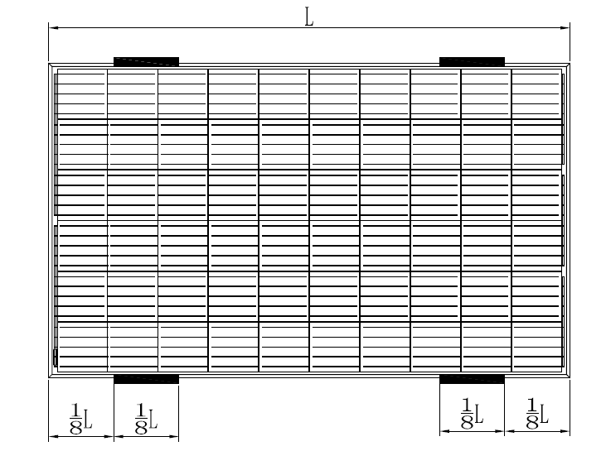 |  |  |  | NO. |  |  |  | L*W(mm)
 |  |  |  | 1 |  |  |  | 1324*992
 |  |  |  | 2 |  |  |  | 1640*826
 |  |  |  | 3 |  |  |  | 1640*992
 |  |  |  | 4 |  |  |  | 1650*992
 |  |  |  | 5 |  |  |  | 1665*992
 |  |  |  | 6 |  |  |  | 1665*1002
 |  |  |  | 7 |  |  |  | 1684*1002
 |  |  |  | 8 |  |  |  | 1755*1038
 |  |  |  | 9 |  |  |  | 1775*1052
 |  |  |  | 10 |  |  |  | 1956*992
 |  |  |  | 11 |  |  |  | 1979*1002
 |  |  |  | 12 |  |  |  | 1987*992
 |  |  |  | 13 |  |  |  | 2008*1002
 |  |  |  | 14 |  |  |  | 2094*1038
 |  |  |  | 15 |  |  |  | 2115*1052
注意: L是组件的长边，W是组件短边，黑色阴影部分为压块安装范围。
短边压块安装-负载≤2400Pa（使用4个压块）
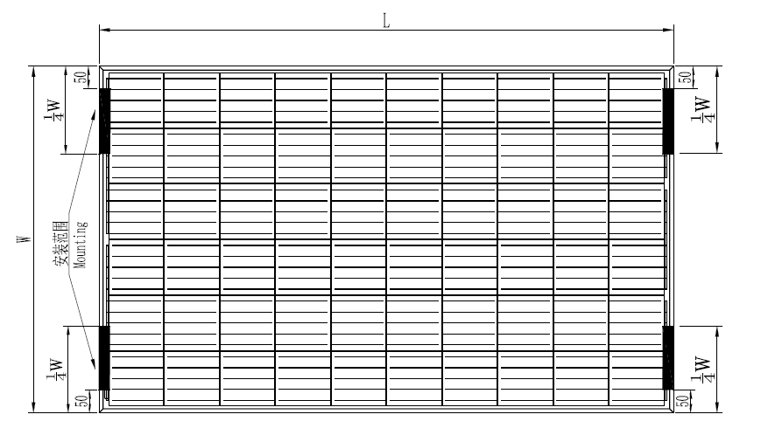 |  |  |  |  | NO. |  | L*W(mm)
 |  |  |  |  | 1 |  | 1324*992
 |  |  |  |  | 2 |  | 1640*826
 |  |  |  |  | 3 |  | 1640*992
 |  |  |  |  | 4 |  | 1650*992
 |  |  |  |  | 5 |  | 1665*992
 |  |  |  |  | 6 |  | 1665*1002
 |  |  |  |  | 7 |  | 1684*1002
 |  |  |  |  | 8 |  | 1755*1038
 |  |  |  |  | 9 |  | 1775*1052
注意: L是组件的长边，W是组件短边，黑色阴影部分为压块安装范围。
长短边压块安装-负载≤2400Pa（使用4个压块）
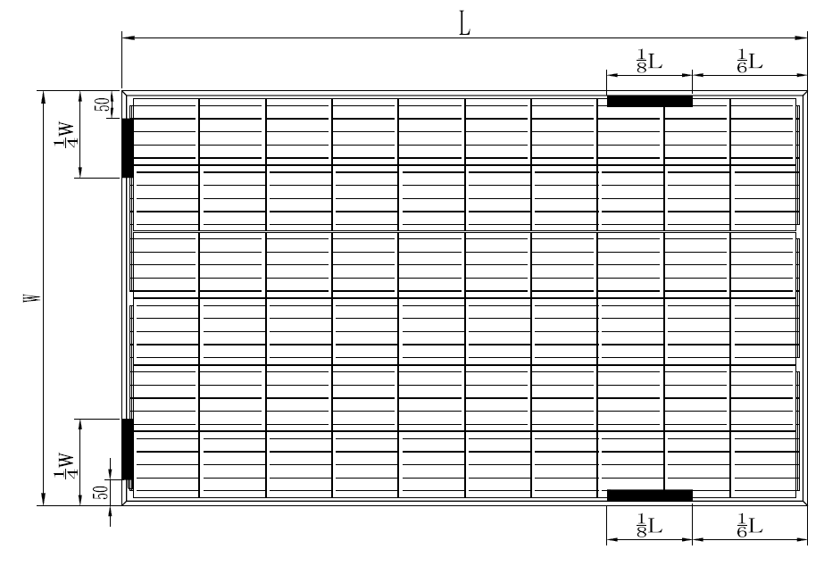 |  |  | NO. |  |  | L*W(mm)
 |  |  | 1 |  |  | 1324*992
 |  |  | 2 |  |  | 1640*826
 |  |  | 3 |  |  | 1640*992
 |  |  | 4 |  |  | 1650*992
 |  |  | 5 |  |  | 1665*992
 |  |  | 6 |  |  | 1665*1002
 |  |  | 7 |  |  | 1684*1002
 |  |  | 8 |  |  | 1755*1038
 |  |  | 9 |  |  | 1775*1052
注意: L是组件的长边，W是组件短边，黑色阴影部分为压块安装范围。
5400Pa≤载荷≤8100Pa(采用6个压块)
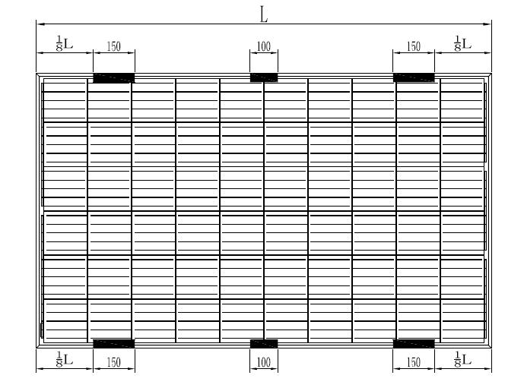 |  | NO. |  |  |  | L*W(mm)
 |  | 1 |  |  |  | 1324*992
 |  | 2 |  |  |  | 1640*826
 |  | 3 |  |  |  | 1640*992
 |  | 4 |  |  |  | 1650*992
 |  | 5 |  |  |  | 1665*992
 |  | 6 |  |  |  | 1665*1002
 |  | 7 |  |  |  | 1684*1002
 |  | 8 |  |  |  | 1755*1038
 |  | 9 |  |  |  | 1775*1052
 |  | 10 |  |  |  | 1956*992
 |  | 11 |  |  |  | 1979*1002
 |  | 12 |  |  |  | 1987*992
 |  | 13 |  |  |  | 2008*1002
 |  | 14 |  |  |  | 2094*1038
 |  | 15 |  |  |  | 2115*1052
注意: L是组件的长边，W是组件短边，黑色阴影部分为压块安装范围。
单边压块(35/40mm可选) | 双边压块
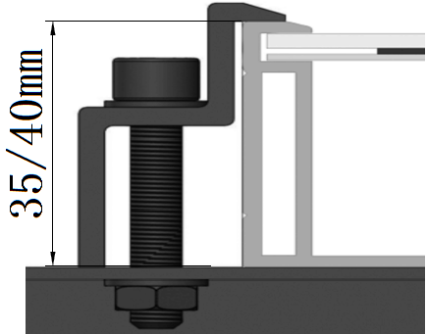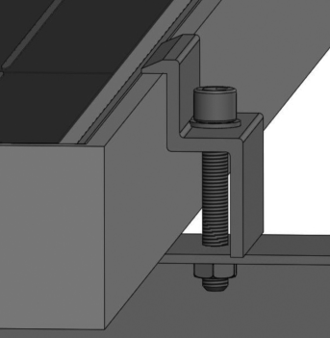 | 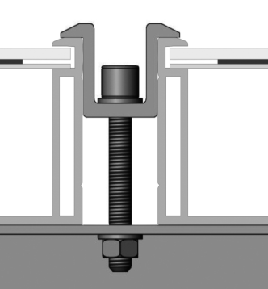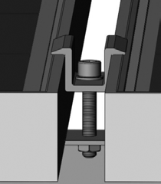
组件采用夹具安装的安装方式。

6.3螺栓安装
每个组件的边框上都有14×9mm的安装孔，理想情况下可以优化组件负载能力，从而将组件固定到支撑结构上。
•为了延长组件安装寿命，我们强烈建议使用防腐蚀（不锈钢）固定件固定组件。
•使用M8螺栓和平垫圈，弹簧垫圈和螺母（如图4所示）将组件固定在每个固定位置，然后拧紧至16-20N·m的扭矩。
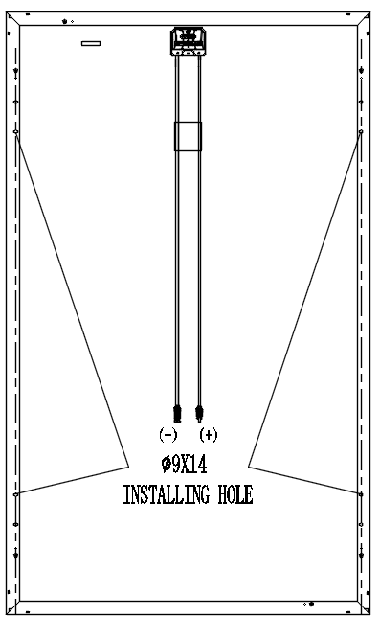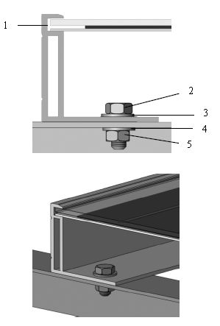
图4 光伏组件的螺栓安装方式

1 铝边框 2 M8不锈钢螺栓
3 平不锈钢垫圈 4 不锈钢弹簧垫圈
5 六角不锈钢螺母

螺栓安装方式
NO. | L*W(mm) | 载荷≤2400Pa | 载荷≤5400Pa
NO. | L*W(mm) | 使用4个带有S或P的安装孔 | 使用4个带有S的安装孔
1 | 1324*992 | 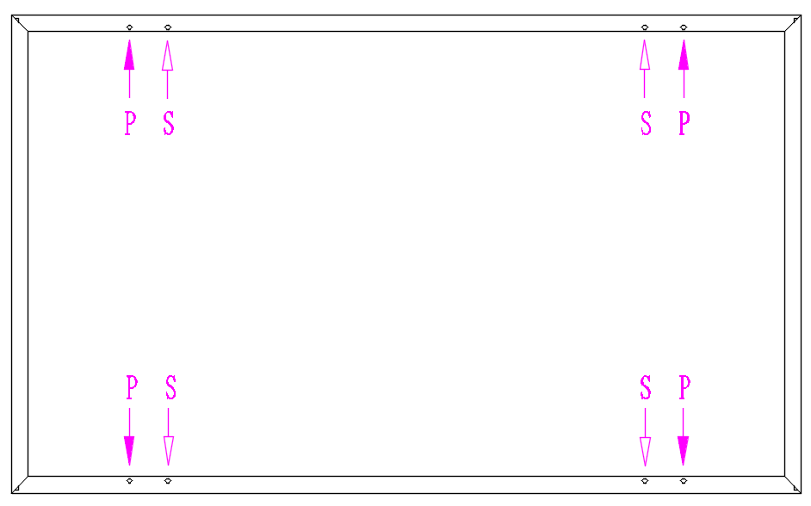
2 | 1640*826
3 | 1640*992
4 | 1650*992
5 | 1665*992
6 | 1665*1002
7 | 1684*1002
8 | 1755*1038
9 | 1775*1052
10 | 1956*992
11 | 1979*1002
12 | 1987*992
13 | 2008*1002
14 | 2094*1038
15 | 2115*1052

6 Modules Installation
6.1 Modules unpacking
6.1.1 When the modules are shipped to installation place, do not unpack modules in humid and rainy weather.
6.1.2 After being unpacked, the modules shall be placed horizontally; the tilt, heap pressure, leaning stack way are prohibited.
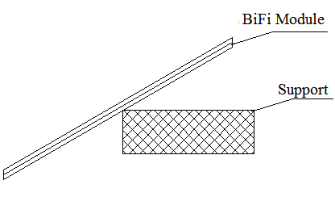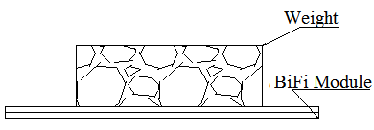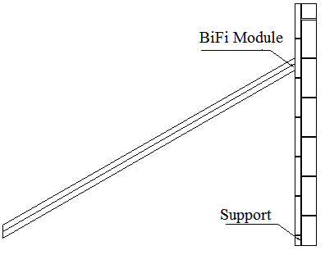
Figure 2 Modules stack illustration
6.1.3 Distance shall be kept between two batches of modules, no more than 23pcs modules shall be piled up together (it is recommended that no more than 23pcs modules whose weight is less than 27kg shall be piled up, and no more than 18pcs modules whose weight is no less than 27kg shall be piled up).
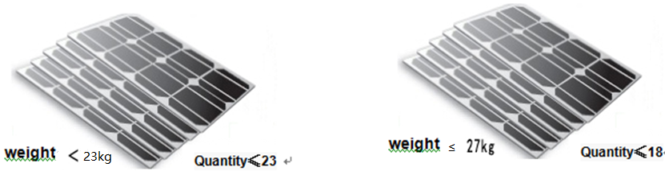
6.1.4 Unpacking the package should refer to the following instructions as Figure 3, Any rude operation or use crowbar unclench into the boxes are prohibited. Pay attention to personal safety and modules safety when using tools.
6.1.5 After unloading, the packing box shall be placed on dry and flat ground, and shall not be placed on wet, muddy and uneven ground;
6.1.6 After the modules are transported to the construction site, the upper and lower boxes shall be separated and placed separately, and the two boxes of modules shall not be stacked; if the modules cannot be installed in time, attention shall be paid to the protection of modules and packing boxes to prevent the damage of natural disasters such as rain, snow, hail, typhoon, etc.
Unpacking paper boxes process
- d dismantling the packing belt of the coaming, the red tape is not dismantled. | - remove packaging side (shaded part).
- r dismantling the packing belt of the modules. | - disassembly modules from side.
Figure 3 Upacking process
6.2 Mounting with Clamps
We have tested its modules with a number of clamps from different manufacturers, fixing use M8. The clamp must overlap the module frame by at least 0.28 in but no more than 0.39 in. All the installation methods described here are for reference only. We are not responsible for the design and installation of relevant modules and photovoltaic systems. Mechanical load and safety of components must be performed by a professional system installer or someone with relevant qualifications.
• Use at minimum 4 clamps to fix modules on the mounting rails.
• Modules clamps should not come into contact with the front glass and must not deform the frame.
• Be sure to avoid shadowing effects from the module clamps.
• The module frame is not to be modified under any circumstances.
• When choosing this type of clamp-mounting method, use at least four clamps on each module, two clamps should be attached on each long sides of the module (for portrait orientation) and each short sides of the module (for landscape orientation). Depending on local wind and snow loads, additional clamps may be required to ensure that modules can bear the load.
• Applied torque should refer to mechanical design standard according to the bolt customer is using, e.g:
M8 ---- 16-20 N·m.

mounting with clamps at longside of module- Load<5400Pa(Using 4 clamps)
 |  |  |  | NO. |  |  |  | L*W(mm)
 |  |  |  | 1 |  |  |  | 1324*992
 |  |  |  | 2 |  |  |  | 1640*826
 |  |  |  | 3 |  |  |  | 1640*992
 |  |  |  | 4 |  |  |  | 1650*992
 |  |  |  | 5 |  |  |  | 1665*992
 |  |  |  | 6 |  |  |  | 1665*1002
 |  |  |  | 7 |  |  |  | 1684*1002
 |  |  |  | 8 |  |  |  | 1755*1038
 |  |  |  | 9 |  |  |  | 1775*1052
 |  |  |  | 10 |  |  |  | 1956*992
 |  |  |  | 11 |  |  |  | 1979*1002
 |  |  |  | 12 |  |  |  | 1987*992
 |  |  |  | 13 |  |  |  | 2008*1002
 |  |  |  | 14 |  |  |  | 2094*1038
 |  |  |  | 15 |  |  |  | 2115*1052
Notes: L is the length of PV module, W is the wide of module ,and the black shaded part is the installation range.
mounting with clamps at shortside of module- Load≤2400Pa(Using 4 clamps)
 |  |  |  |  | NO. |  | L*W(mm)
 |  |  |  |  | 1 |  | 1324*992
 |  |  |  |  | 2 |  | 1640*826
 |  |  |  |  | 3 |  | 1640*992
 |  |  |  |  | 4 |  | 1650*992
 |  |  |  |  | 5 |  | 1665*992
 |  |  |  |  | 6 |  | 1665*1002
 |  |  |  |  | 7 |  | 1684*1002
 |  |  |  |  | 8 |  | 1755*1038
 |  |  |  |  | 9 |  | 1775*1052
Notes: L is the length of PV module, W is the wide of module ,and the black shaded part is the installation range.
mounting with clamps at both longside & shortside of module- Load≤2400Pa(Using 4 clamps)
 |  |  | NO. |  |  | L*W(mm)
 |  |  | 1 |  |  | 1324*992
 |  |  | 2 |  |  | 1640*826
 |  |  | 3 |  |  | 1640*992
 |  |  | 4 |  |  | 1650*992
 |  |  | 5 |  |  | 1665*992
 |  |  | 6 |  |  | 1665*1002
 |  |  | 7 |  |  | 1684*1002
 |  |  | 8 |  |  | 1755*1038
 |  |  | 9 |  |  | 1775*1052
Notes: L is the length of PV module, W is the wide of module ,and the black shaded part is the installation range.
5400Pa≤Load≤8100Pa(Using 6 clamps)
 |  | NO. |  |  |  | L*W(mm)
 |  | 1 |  |  |  | 1324*992
 |  | 2 |  |  |  | 1640*826
 |  | 3 |  |  |  | 1640*992
 |  | 4 |  |  |  | 1650*992
 |  | 5 |  |  |  | 1665*992
 |  | 6 |  |  |  | 1665*1002
 |  | 7 |  |  |  | 1684*1002
 |  | 8 |  |  |  | 1755*1038
 |  | 9 |  |  |  | 1775*1052
 |  | 10 |  |  |  | 1956*992
 |  | 11 |  |  |  | 1979*1002
 |  | 12 |  |  |  | 1987*992
 |  | 13 |  |  |  | 2008*1002
 |  | 14 |  |  |  | 2094*1038
 |  | 15 |  |  |  | 2115*1052
Notes: L is the length of PV module, W is the wide of module ,and the black shaded part is the installation range.
End Clamp installation(35/40mm optional) | Middle Clamp installation
PV module installed with clamp fitting method.

6.3 Mounting with Bolts
The frame of each module has 14 x 9mm mounting holes, ideally placed to optimize the load handling capability, to secure the modules to supporting structure.
• To maximize mounting longevity, our Solar strongly recommends using corrosion proof (stainless steel) fixings.
• Secure the module in each fixing location with an M8 bolt and a flat washer, spring washer and nut as shown in Figure 4 and tighten to a torque of 16-20 N·m.
Figure 4. SPV module installed with Bolt fitting method
1 Aluminum Frame 2 M8 Stainless bolt
3 Flat Stainless Washer 4 Spring Stainless Washer
5 HEX Stainless Nut
Mounting with Bolts
NO. | L*W(mm) | Load≤2400Pa | Load≤5400Pa
NO. | L*W(mm) | Using 4 installation holes with S or P holes | Using 4 installation holes with S holes
1 | 1324*992
2 | 1640*826
3 | 1640*992
4 | 1650*992
5 | 1665*992
6 | 1665*1002
7 | 1684*1002
8 | 1755*1038
9 | 1775*1052
10 | 1956*992
11 | 1979*1002
12 | 1987*992
13 | 2008*1002
14 | 2094*1038
15 | 2115*1052

7 电气连接
7.1接线前请仔细阅读该光伏系统电气布线图纸，对于IEC标准组件最大系统电压不超过DC1500V 。 7.2组件和接线箱的连接：使用直流电缆将组件串与接线箱相连。电缆的横截面积和连接器容量必须满足系统的短路电流(用于单个组件的电缆线横截面积推荐为4mm²，电缆的最小直径和最大外直径是5-7mm, 保险丝电流大于或等于15A，连接器的额定电流大于15A )，否则电缆线和连接器会因为大电流而过热。请注意电缆承受温度的上限为90℃，连接器承受温度的上限为125℃。
7.3组件铝边框和组件支架必须接地，每个组件有四个接地孔，并在边框上做标记(建议每个组件的串联/并联必须接地一次)。接地孔的具体位置如下图所示。接地线和边框将通过预留接地孔可靠接地，通过安装螺栓M5×10 ~ 15匹配平垫圈、弹簧垫圈和螺母。组件和接地线应通过接线头完美连接。可安装负极接地逆变器，防止PID现象。
7.4如果使用常见的接地硬件(螺母、螺栓、星形垫圈、开环锁紧垫圈、平板垫圈等)用来连接接地/连接装置，安装时必须按照接地配件制造商的说明进行。
7.5常见的接地连接硬件项目如螺母、螺栓、星形垫圈、锁紧垫圈等还没被评估电导率的硬件，只能用于维护机械连接，并保持适当的接地装置的导电率。这些硬件随组件一起提供并按要求通过UL 1703中的评估，可用于根据组件安装说明进行接地连接。
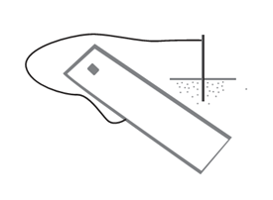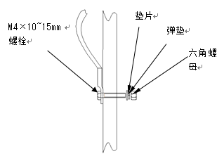
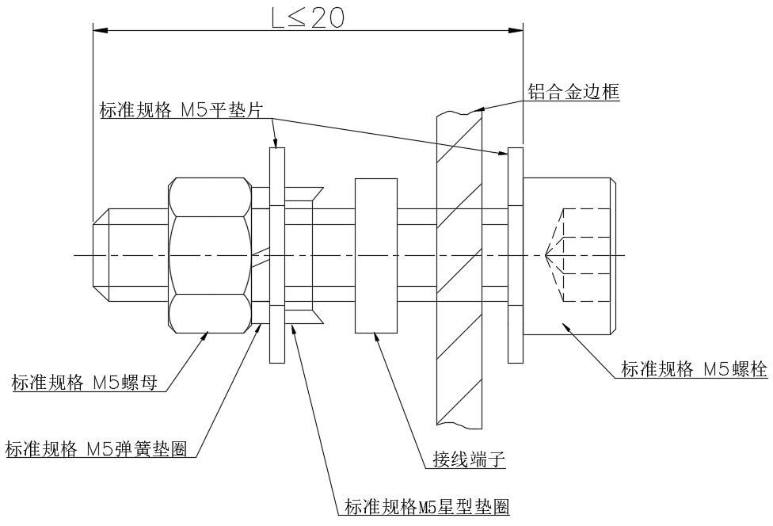
7.6电气连接应符合当地电气法规，组件系统电气连接不允许出现“Y”型电气连接方式。
7.7组件中装有旁路二极管（额定电压45V，额定电流20A）如出现不正确的安装，二极管、电缆和接线盒可能会受到破坏。
7.8组件取出后，在不立即安装的情况下需保护好连接器，以免因风或雨造成损坏。禁止在连接器上使用润滑剂，因为它会导致连接器失效。
7.9切勿将防水胶环从接线盒或连接器上拆下。
7.10 安装现场严禁使用柴油取暖。柴油和其他石油产品燃烧产生的气体可能损坏连接器。

7 Electrical connection
7.1 Please read the electrical wiring drawings carefully before wiring, when the modules followed the IEC standard,the maximum system voltage is 1500V DC.
7.2 The connection of module and junction box: the module is connected with junction box by a dc cable. The cross-sectional area of cable and the connector capacity must be satisfied the system's short circuit current (the cable's cross-sectional area for a single module is recommended to be 4mm², The outer diameter of the cable could be selected 5-7mm. The fuse current and the rated current of the connector should be higher than 15A.) Otherwise, the cables and connectors will overheat due to high current. Please note that the highest temperature of cable is 90 ℃, and the highest temperature of connector is 125 ℃.
7.3 Aluminum frame and brackets of modules must be grounded with four ground holes of each module, which is marked on frames (it is recommended that each series/parallel of modules should be grounded once). The specific location of the grounding holes can be seen as the figure below. The ground wire and frame will be reliable grounding through the reserve grounding holes,by the installation bolts M5X10 ~ 15 matching plain washers, spring washers and nuts. Modules and ground cables shall be connected perfectly by wiring nose. Negative grounded inverters can be installed to prevent PID phenomenon.
7.4 Where common grounding hardware (nuts, bolts, star washers, spilt-ring lock washers, flat washers and the like) is used to attach a listed grounding/bonding device, the attachment must be made in conformance with the grounding device manufacturer's instructions.
7.5 Common hardware items such as nuts, bolts, star washers, lock washers and the like have not been evaluated for electrical conductivity or for use as grounding devices and should be used only for maintaining mechanical connections and holding electrical grounding devices in the proper position for electrical conductivity. Such devices, where supplied with the module and evaluated through the requirements in UL 1703, may be used for grounding connections in accordance with the instructions provided with the module.
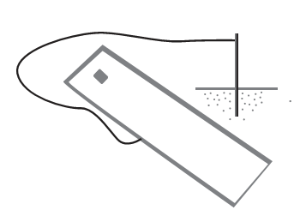
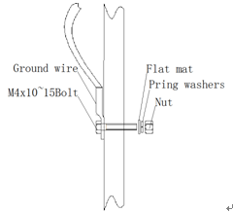

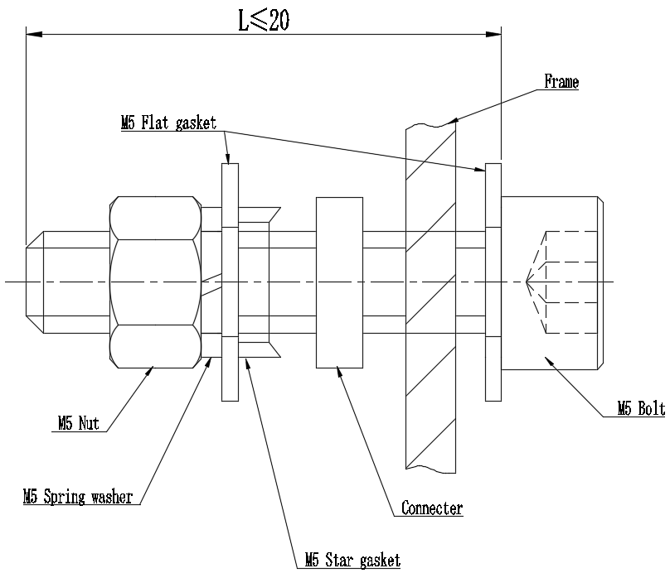
7.6 The electrical connection shall conform to local electrical laws and regulations, "Y" type electrical connection mode is not allowed in module system electrical connection.
7.7 Modules are equipped with bypass diodes（rated voltage 45V, rated current 20A）; improper installation may damage diodes, cables or wiring box.
7.8 Please wrap the connectors after taking out the modules without immediate installation so as to prevent damage caused by wind or rain. Use of lubricant for connectors is prohibited, because it leads fracture of connectors.
7.9 Do not remove the waterproof rubber rings out of the junction box or connectors.
7.10 Use of diesel oil for heating is strictly prohibited at installation site, which may lead to connector failure because the gas after combustion of diesel and other petroleum products.
8 保养维护
8.1组件需要定期进行检查和维护，包括所有的电气连接，确保没有开路，连接良好。
8.1.1 检查每个组件的开路电压：
8.1.2 用一块不透明的材料完全覆盖组件。
8.1.3 断开组件两端的导线。
8.1.4 取掉组件上的不透明材料，检查并测量终端的开路电压。
8.1.5 如果测量的电压减少1/4以上，可能是旁路二极管损坏，请测试旁路二极管性能。
8.2推荐下列维护措施以确保组件的最佳性能：
8.2.1 检查组件是否存在外观缺陷：组件表面是否有破损、异常，组件是否被物品等遮挡，组件与支架之间的固定是否存在松动，发现异常后需联系有资质或经验的维护人员进行调整或修复。
8.2.2 尽可能每年清洁一次组件，可根据当地具体情况而定。组件表面出现脏污时，会减少发电量。清洁时，可以使用软海绵或抹布沾水清洁组件的玻璃表面。可使用温和的，不加研磨剂的清洗剂去除顽垢。严禁使用具有腐蚀性的化学清洁剂。为减少电击或灼伤，建议在清晨或傍晚进行组件清洁工作。
8.2.3 每6个月进行机械和电气检查，确保组件接头清洁及连接可靠、确保组件电气连接良好，无腐蚀现象。
8.2.4如有任何疑问，请具有资质的人员进行检查。
8.2.5 遵守系统使用的所有部件，如支架、充电整流器、逆变器、电池等的维护说明。

8 Maintenance
8.1Modules need to be inspected and maintained regularly, check all electrical connections to ensure that there is no open circuit and well connected.
8.1.1 Check the open circuit voltage of each module:
8.1.2 Covered the modules completely by non-transparent material.
8.1.3 Disconnect the wire terminals
8.1.4 Remove the non-transparent material off the modules; check and measure the terminal open circuit voltage.
8.1.5 If the measured voltage is reduced by 1/4, it supposed to be bypass diode damaged. Please test the bypass diode performance.
8.2 It’s recommend that adopt the following maintenance to ensure the modules maintain the best performance:
8.2.1 Check whether the modules have appearance defects: whether the surface of the modules are damaged or abnormal, whether the modules are occluded by objects, whether the fixing between the modules and the frame is loose or not, and contact qualified or experienced maintenance personnel to adjust or repair after finding the abnormalities.
8.2.2 Clean modules once a year as much as possible, depending on local conditions. When dirt appears on the surface of modules, it will reduce the power generation. When cleaning, a soft sponge or a rag can be used to wet the glass surface of the modules. A mild, non-abrasive detergent can be used to remove fouling. The use of corrosive chemical cleaners is strictly prohibited. In order to reduce electric shock or burns, it is recommended to clean modules in the morning or evening.
8.2.3 Mechanical and electrical checks are required every six months to ensure the modules’ connectors clean and reliable connected.And ensure good electrical connection and no corrosion.
8.2.4 It need ask qualified person to check the modules if have any doubt on the modules.
8.2.5 Please note that all maintenance instructions, such as brackets, charging rectifier, inverters and batteries, shall be complied.

9 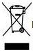 交叉轮式垃圾箱的意义
不要将电器作为未分类的城市垃圾处理，使用单独的收集设施。有关可用的的收集系统的信息，请与当地政府联系。如果电器是在垃圾填埋场或垃圾场处理的，有害物质会渗入地下水，进入食物链，损害你的健康。当用新电器替换旧电器时，零售商在法律上有义务收回旧电器进行处置，至少是免费的。
9 Meaning of crossed –out wheeled dustbin:
Do not dispose of electrical appliances as unsorted municipal waste, use separate collection facilities.
Contact your local government for information regarding the collection systems available.
If electrical appliances are disposed of in landfills or dumps, hazardous substances can leak into the groundwater and get into the food chain, damaging your health and well-being.
When replacing old appliances with new ones, the retailer is legally obligated to take back your old appliance for disposals at least free of charge.

10 免责声明
由于本手册的使用及组件安装、操作、使用和维护条件超出了神舟的控制范围，神舟不承担任何因安装、操作、使用或维护中所引起的损失、破坏或费用责任。
神舟不承担任何由于使用组件产品可能导致的侵犯专利和第三方权利的责任。客户并不因使用神舟产品而获得任何专利或者专利权利的使用授权，无论是明示的或隐含的。
本手册的信息基于神舟的被认为是可靠的知识和经验，但是包括但不限于如上的产品规格的这些信息和相关的建议并不构成任何保证条款，无论明示的或隐含的。神舟保留修改手册、PV产品、规格或产品信息的权利，无需提前通知。
10 Disclaimer of Liability
Because the use of the manual and the conditions or methods of installation, operation, use and maintenance of photovoltaic (PV) product are beyond the control of Lianyungang Shenzhou New Energy Co.,Ltd.We do not accept responsibility and expressly disclaims liability for loss ,damage, or expense arising out of or in any way connected with such installation, operation, use or maintenance.
No responsibility is assumed by Lianyungang Shenzhou New Energy Co.,Ltd. for any infringement of patents or other rights of third parties, which may result from use of the PV product. NO license is granted by implication or otherwise under any patent or patent rights.
The information in this manual is based on our knowledge and experience and is believed to be reliable, but such information including product specification (without limitations) and suggestions do not constitute a warranty, expresses or implied. We reserve the right to change the manual, the PV produce, the specifications, or product information sheets without prior notice

